**Lesson 16**

**Worksheet (WS)**

**Unit 2020 : Electrical science**

**Worksheet 10: Series/parallel resistive circuits**

**Work sheet (WS)** **2**

**Generic information:** **2**

**WS Question one** **3**

**WS Question two** **4**

**WS Question three** **5**

**WS Question four** **5**

**WS Question five** **8**

**WS Question six** **9**

**WS Question seven** **9**

**WS Question eight** **10**

**WS Question nine** **11**

**Question ten** **12**

# Work sheet (WS)

# 

# 

# 

# Generic information:

In a series circuit we add all of the resistance/resistors.

Whereas, in a Parallel circuit we use the formula.

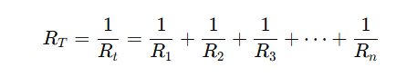

# WS Question one

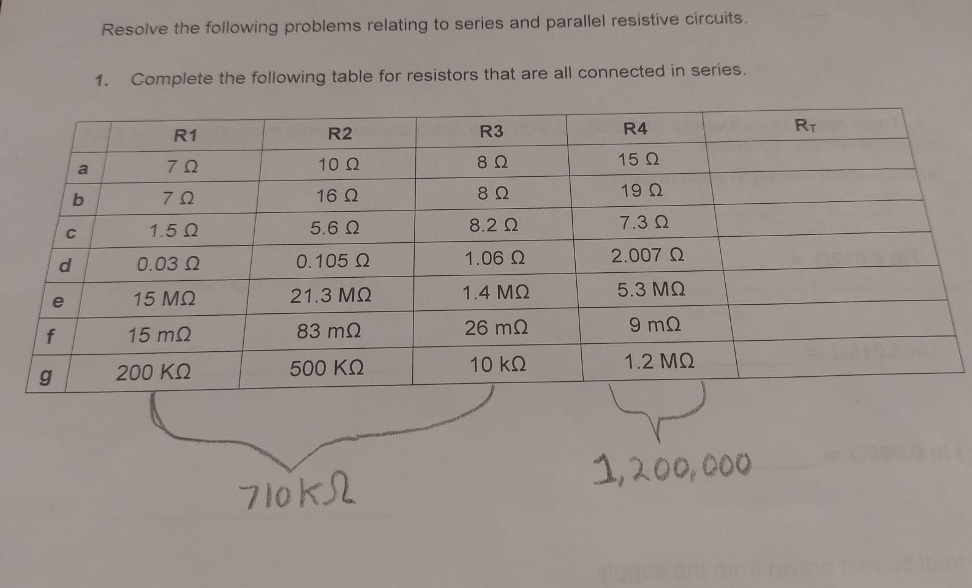

|  | **R1** | **R2** | **R3** | **R4** | **Rt** |
| --- | --- | --- | --- | --- | --- |
| **a** | 7 Ω | 10 Ω | 8 Ω | 15 Ω | **40 Ω** |
| **b** | 7 Ω | 16 Ω | 8 Ω | 19 Ω | **50 Ω** |
| **c** | 1.5 Ω | 5.6 Ω | 8.2 Ω | 7.3 Ω | **22.6Ω** |
| **d** | 0.03 Ω | 0.105 Ω | 1.06 Ω | 2.007 Ω | **3.202Ω** |
| **e** | 15 MΩ | 21.3 MΩ | 1.4 MΩ | 5.3 MΩ | **43MΩ** |
| **f** | 15 mΩ | 83 mΩ | 26 mΩ | 9 mΩ | **133MΩ** |
| **g** | 200 KΩ | 500 KΩ | 10 kΩ | 1.2 MΩ | **1.91MΩ** |

**Question one working out**

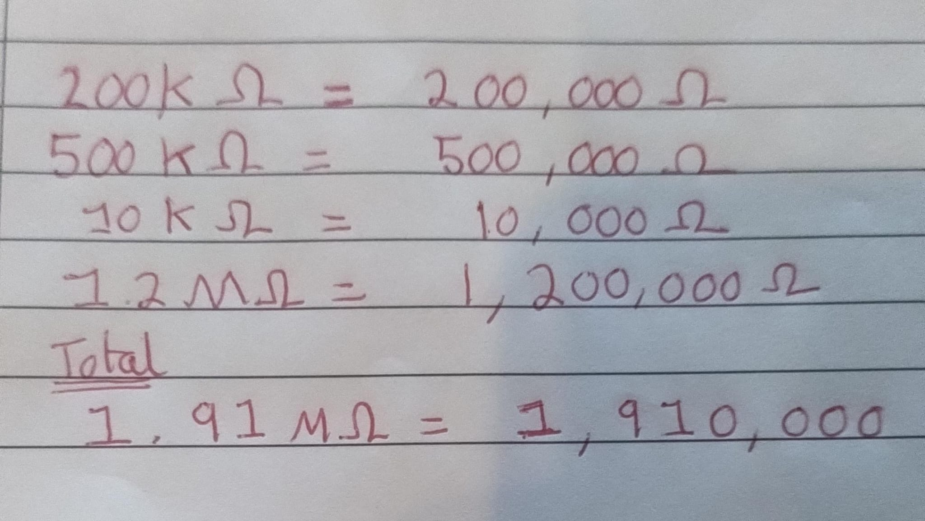

# WS Question two

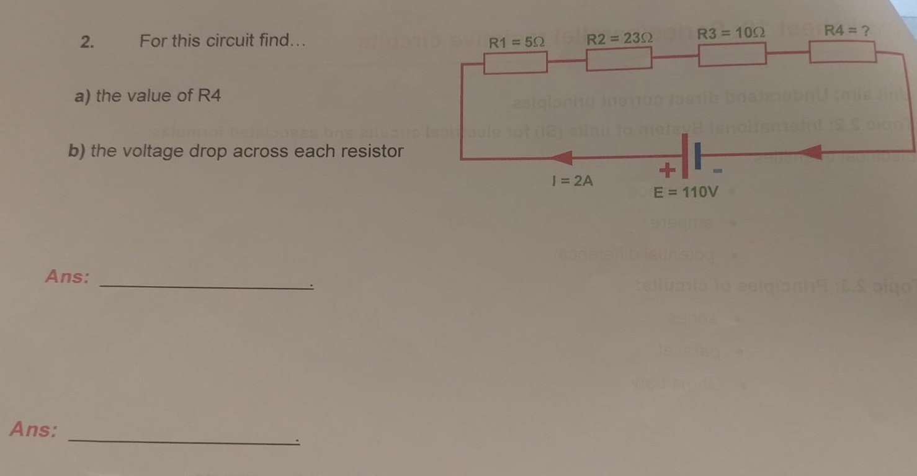

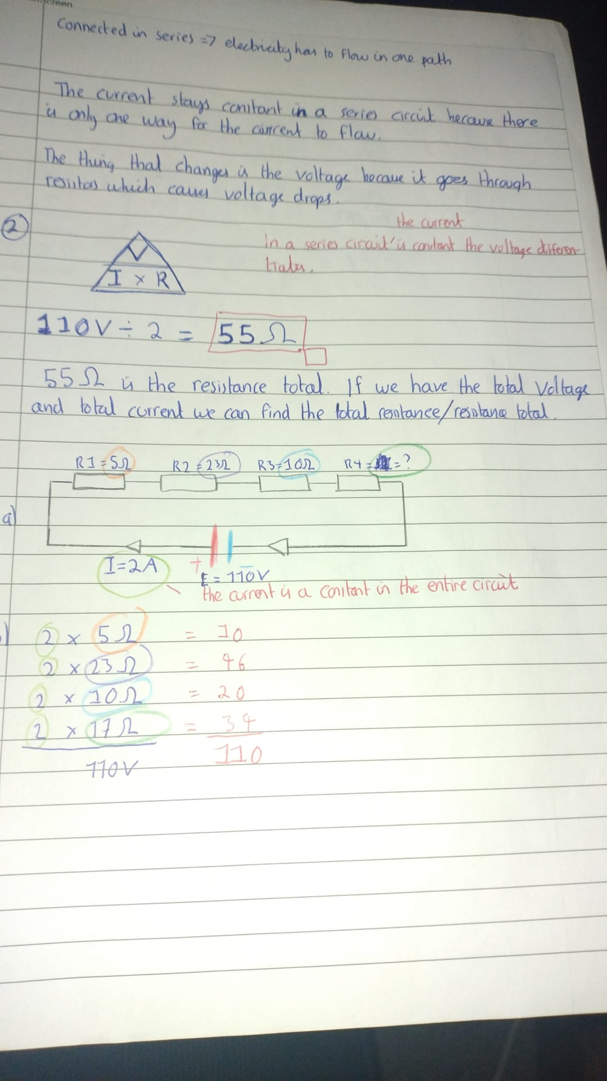

**2 a) working out**

In a series circuit the **current** is constant. Whereas, in the series circuit the **voltage** changes. We have to deduce the value of **R4**. For the resistances we have:

**R1** = 5 ohms,

**R2** = 23 ohms,

**R3** = 10 ohms,

**R4** = ?

The Ohms law triangle.

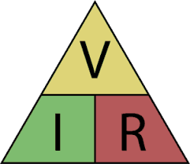

**110 V** / **2A** = **55 ohms**

**55 Ohms** is the **total resistance** for the entire circuit.

**R1 (**5 ohms) + **R2** (23 ohms) + **R3** (10 ohms) = 38 ohms

Hence, **R4** = 17 ohms.

Because, 38 + 17 = 55 ohms.

**2 b) working out**

**Voltage drop in a resistor** = **Current** x **resistance of resistor**

| **Resistor** | **Current** | Resistance per resistor | Voltage drop per resistor |
| --- | --- | --- | --- |
| **R1** | **2** | 5Ω | 10 |
| **R2** | **2** | 23Ω | 46 |
| **R3** | **2** | 10Ω | 20 |
| **R4** | **2** | 17Ω | 34 |
|  |  | Voltage drop total | 110V |

The way to figure out if you have calculated voltage drop properly. Is that the total voltage drop should equal the voltage of the entire circuit.

# WS Question three

# 

Calculate the current following through each resistor



A) The current flowing in the resistor

**R3** => 2.4 V /0.012 ohms = 200 amps

**R2** => 2.4 V /0.015 ohms = 160 amps

**R1** => 2.4 V /0.008 ohms = 300 amps

B) The total current drawn from the supply

**Total Current** = **Total Voltage** / **Total Resistance**

**2.4** / (**200** + **160** + **300** = **660**)

= **0.035 amps**

# 

# WS Question four

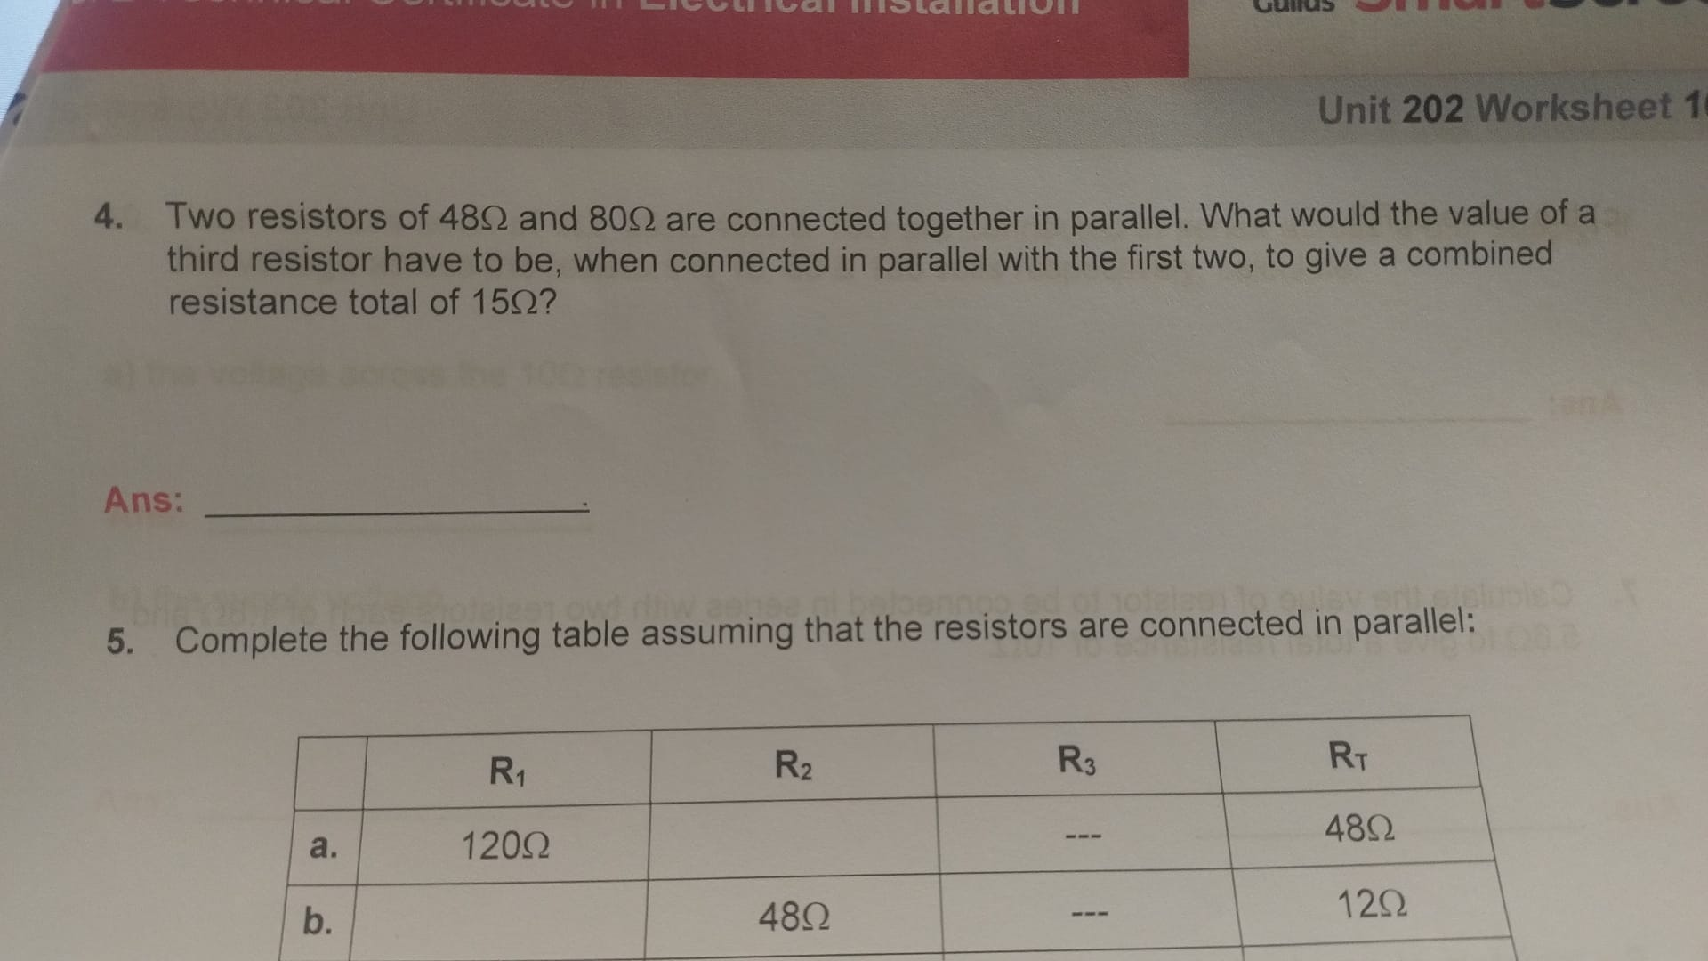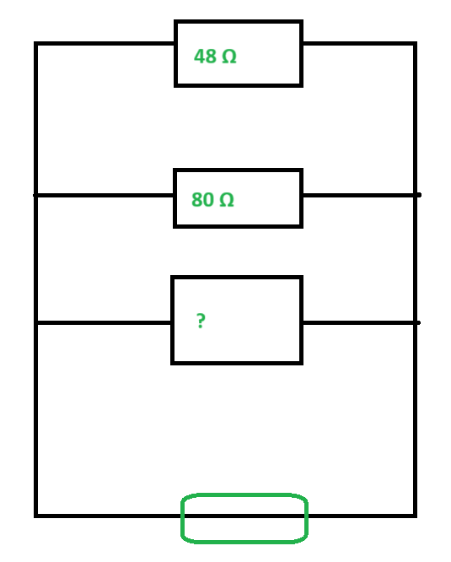

**Question four working out**

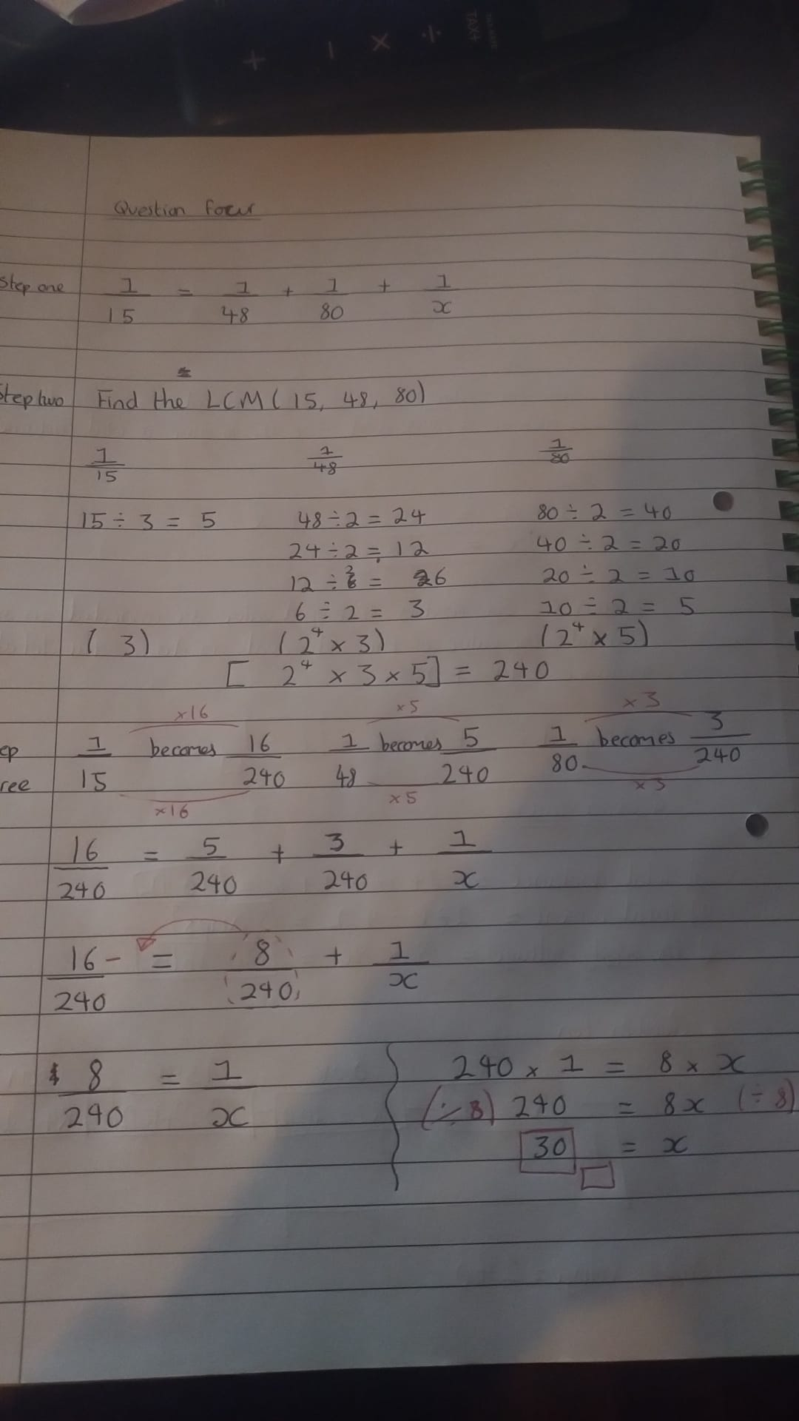

# WS Question five

# 

**Question five working out**

**Row A) R2 = 80 Ω**

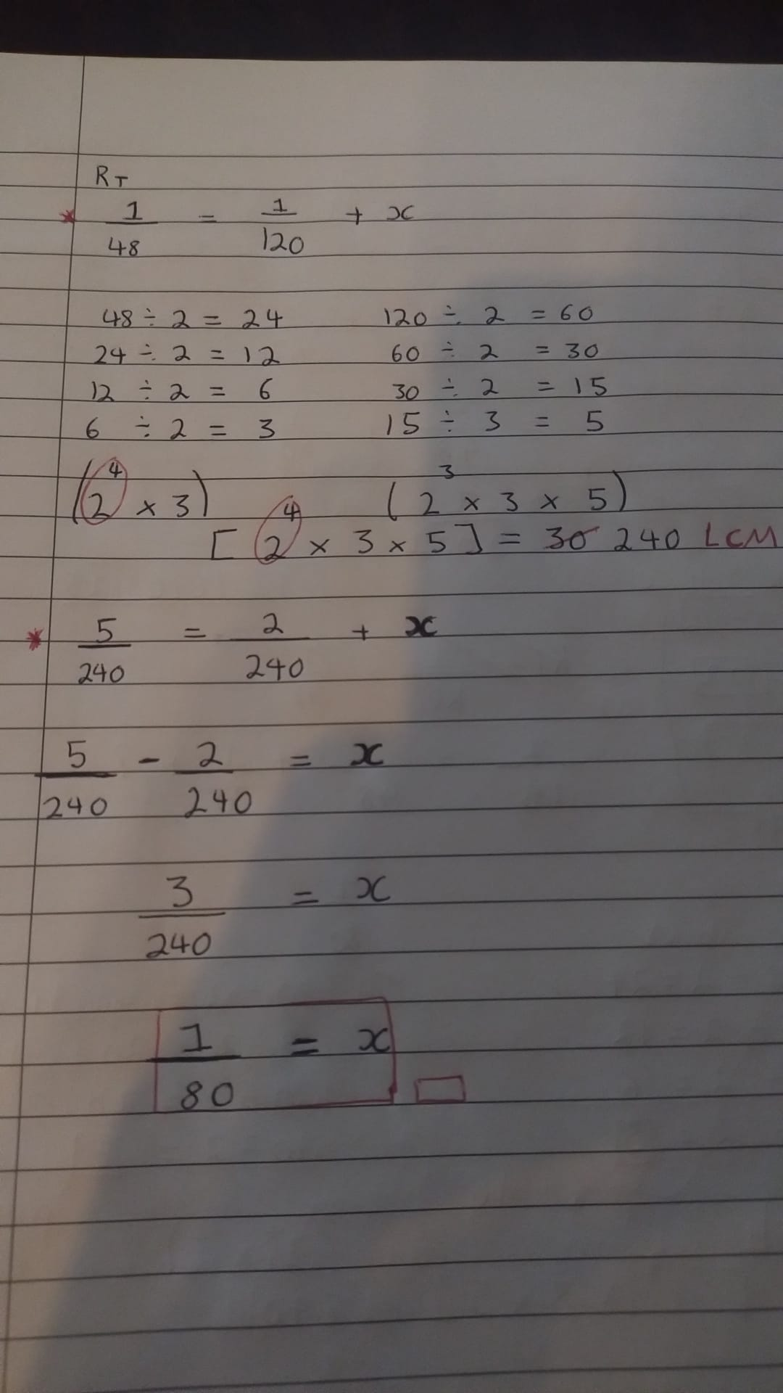

**Row B) R1 = 16 Ω**

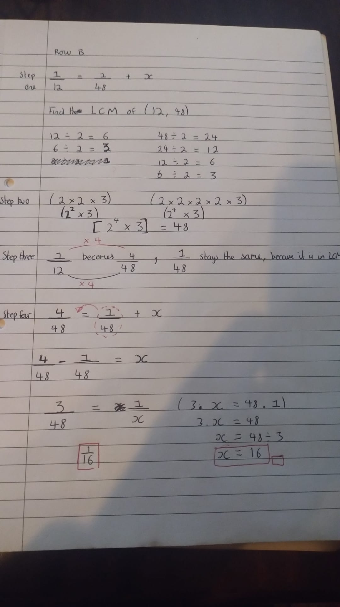

**Row C) R1 = 200 Ω**

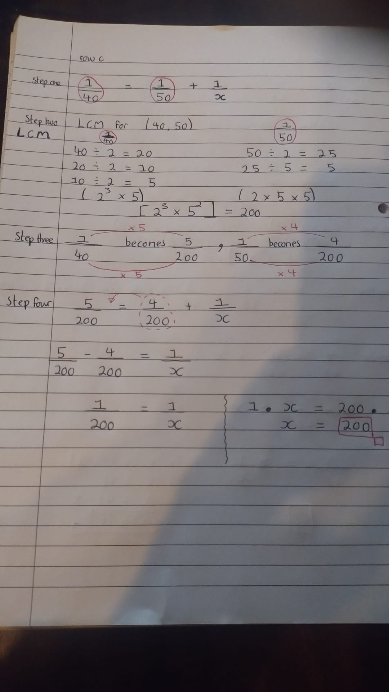

**Row D) R2 = 40Ω**

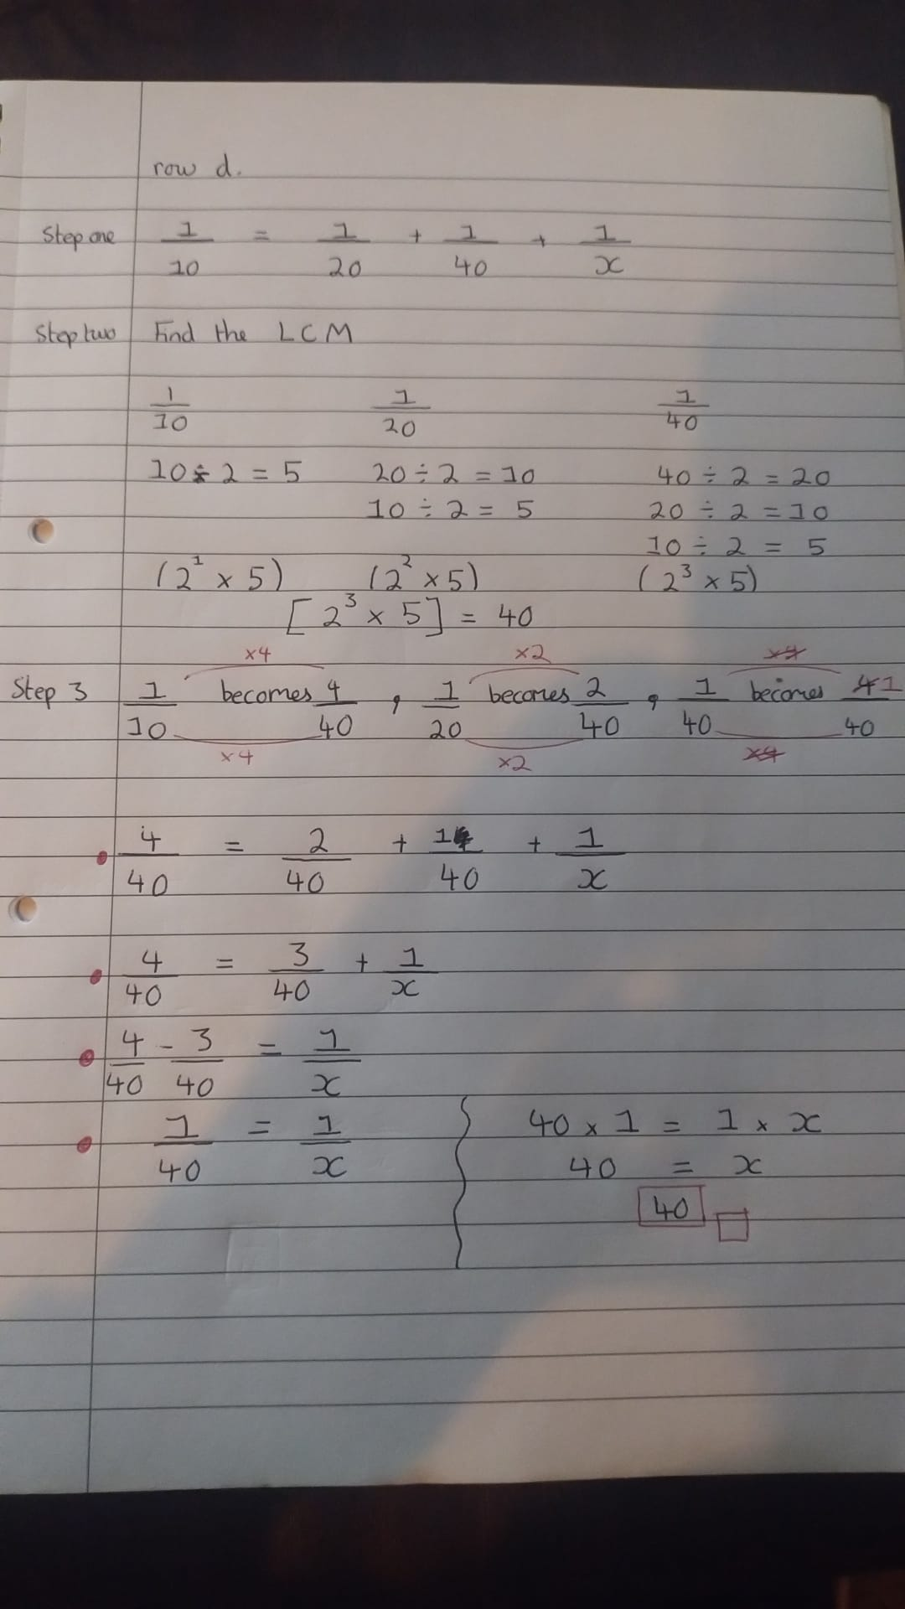

**Row E) R2 = 30Ω**

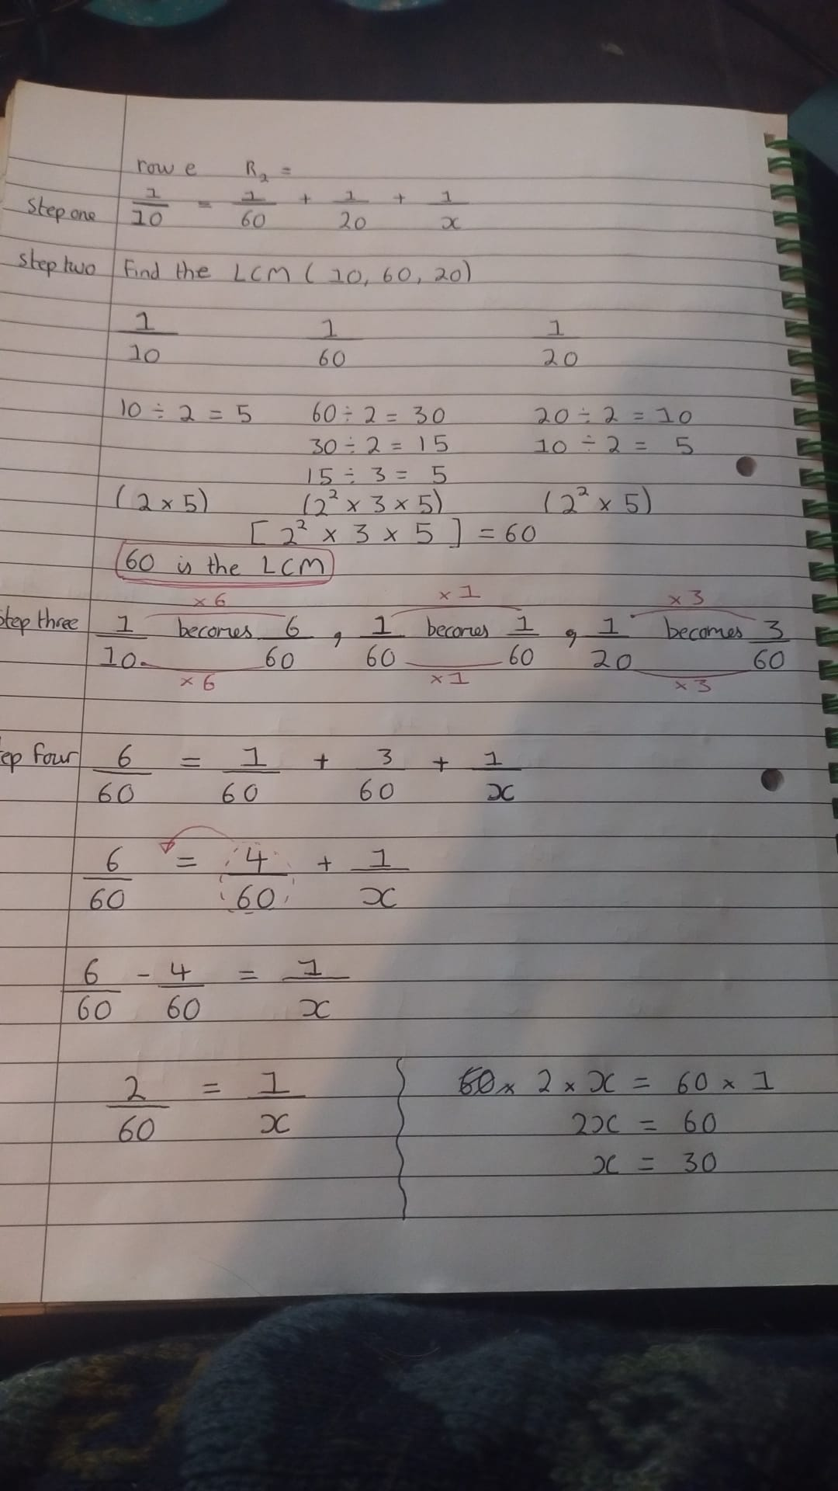

# WS Question six

# WS Question seven

# 

**Question seven working out**

# 

# WS Question eight

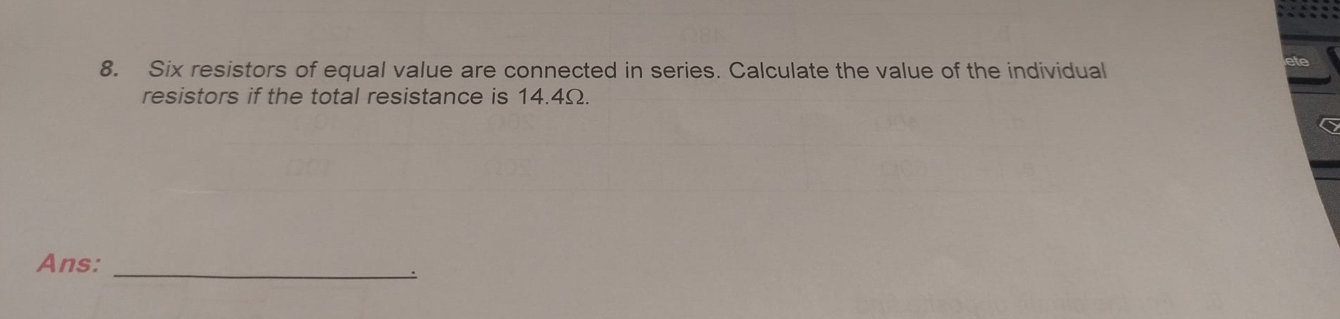

**Question eight working out**

In a series circuit we add the resistor values together to get the Resistance Total (Rt).

In this case we divide 14.4 ohms by 6 to get the individual resistor values. The answer is 2.4.

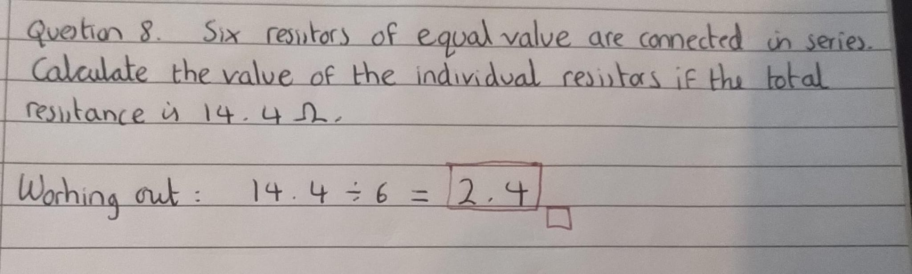

# WS Question nine

**Question nine working out**

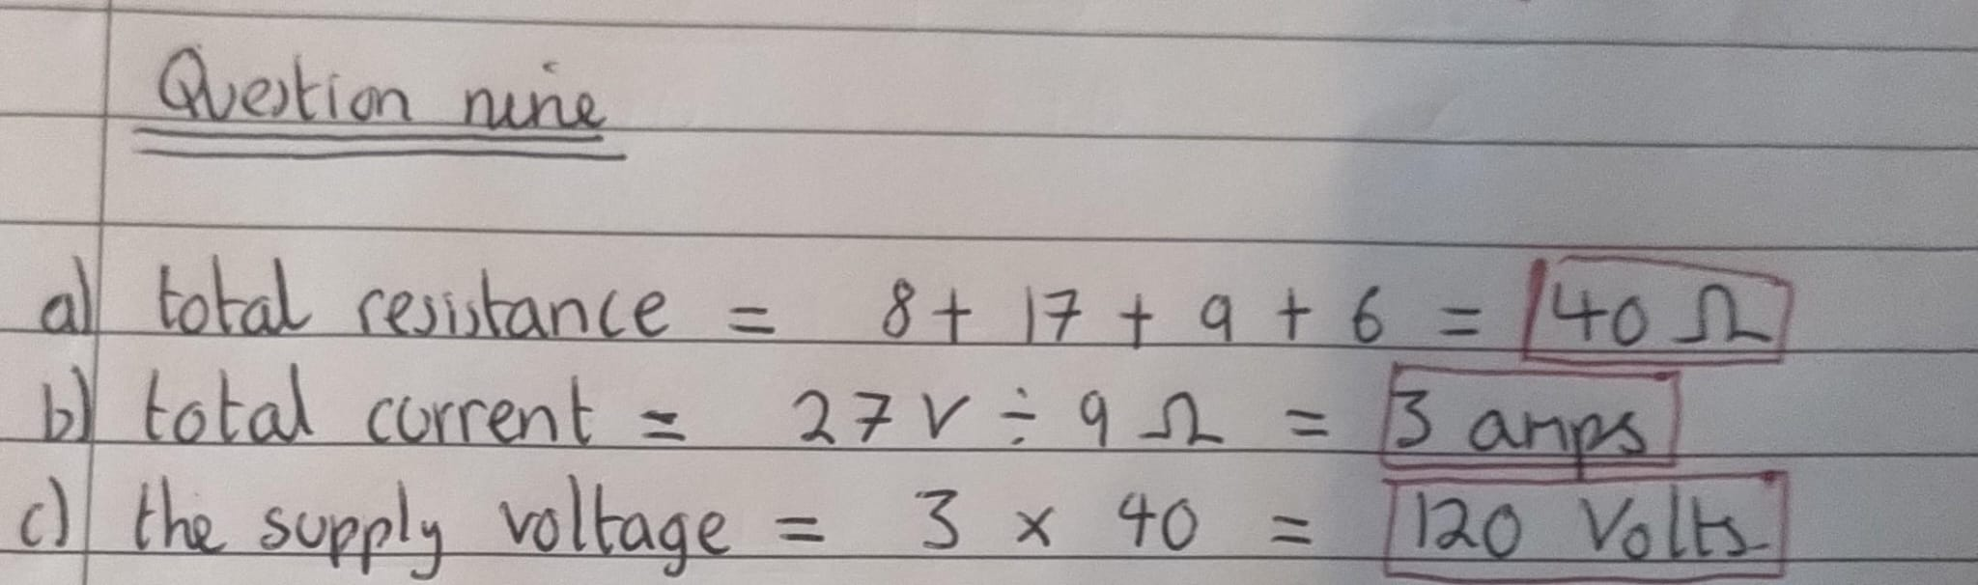

# Question ten

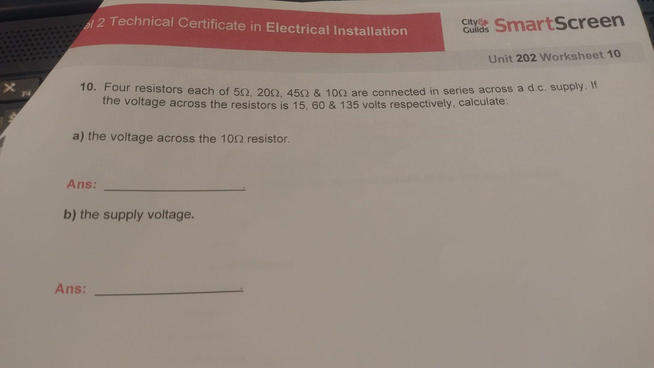

**Question ten working out**

